High-Level Design
Project Name Login Less Email Program Enrollment
Project Number PR00014811 Initial Release Date TBD
Author Sai Priya Buggineni Last Revised Date 03/27/2019
Application/Area Internet Solutions Project Sponsor Jason Stancliff

Approvals

Use the Approval Repository to obtain and document the required approvals.

Reminder:
The BT PM needs to complete the “Project Control Gate: Design” form at the beginning of the design process. The responses on the form will indicate whether this project needs additional reviews from areas such as ARB, Disaster Recovery, etc. The form can be found on the EIS Service Catalog (DTODAY / Applications tab / EIS Service Catalog link) tool.

History of Revisions

Revision Date | Version # | Description of Revision | Revision Requested By | Revision Made By
03/27/2019 | 1.0 | Initial Design |  | Sai Priya Buggineni
03/27/2019 | 2.0 | Design changes |  | Sai Priya Buggineni
03/27/2019 | 3.0 | Change the design to use Redis |  | Sai Priya Buggineni

Table of Contents
Overview 3
Teams Involved 3
Scope of Design (check applicable) 3
Problem Statement 3
Benefits 3
Known Technology and/or Business Risks 3
Assumptions 3
Solutions Diagram 4
System Relationships 5
Current 5
Proposed 5
Internal Processing Flow 7
Current 7
Proposed 7
Data 8
Network to Network Connection 8
Security 8
Glossary 9
Appendix A: System Availability 10
Redundancy Requirements 10
Components Requiring Duplication 10
Data Recovery 10
Risk Containment Plan 10
Impact of Failure by Key Components 10

Overview

Teams Involved
Name | Team
Tushar Nimkar | Application Development
Sai Priya Buggineni | Application Development
Nagesh Basana | Application Development

Scope of Design (check applicable)
 | New System(s) |  | Existing System(s) | √ | Both New and Existing System(s)

 | Program-level Design | √ | Project-level Design |  | Application / System-level Only

Problem Statement
Discover provides an option for eligible card members to enroll in payment programs and the current process requires card member to login to the Discover.com to enroll. CMA business identified eligible card members who cannot/haven’t logged into Account Center in a long time and want to target them via email. Upon clicking on the link in the email, card member can enroll into payment programs without logging into account center.

Benefits
Provides the ability for certain delinquent/pre-delinquent card members to enroll into payment programs without logging in. This will increase the enrollment rates.

Known Technology and/or Business Risks
This project will involve changing the OneClick API and creating new web application to service clicks from emails. Redis would be used to cache intermediate data that user enter in the payment program enrollment process.

Assumptions
None.

Solutions Diagram

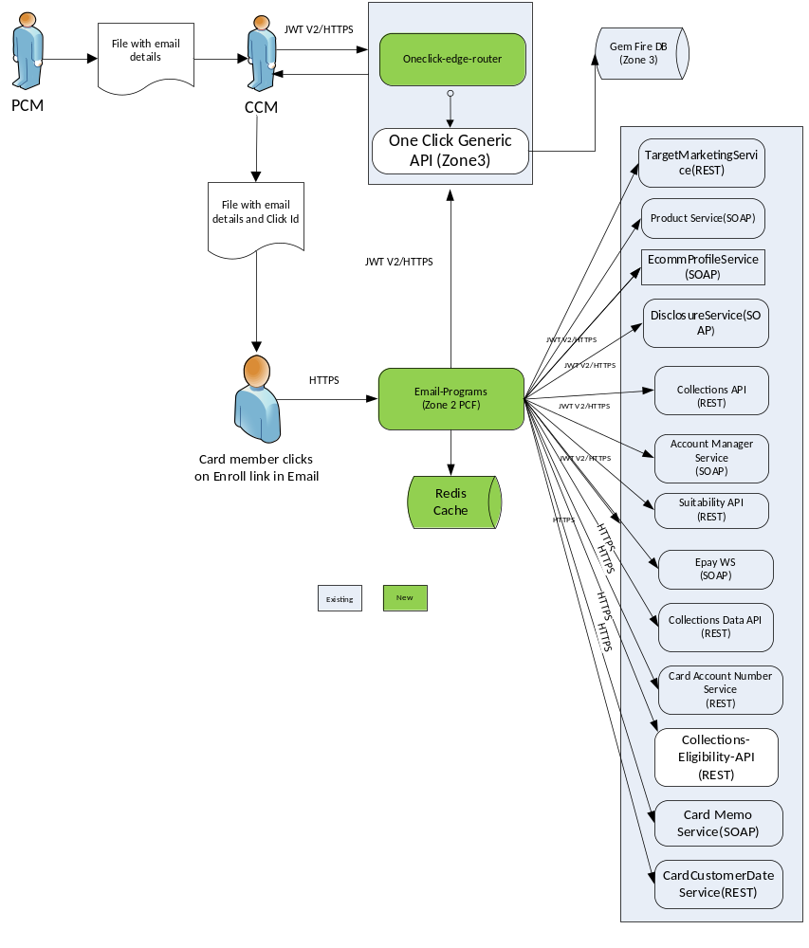

System Relationships

Current

NA

Proposed

The proposed solutions is to use the existing One-Click API set up and create a new generic processor. Based on the path parameters and input, generic processor will decide and route the request to Login less enrollment logic. One Click Gem fire cache will hold:

- account key (EDS Key)
- Generated Click Id
- Action Type (EPE)
- Status

CCM invokes the One Click API’s POST /oneclick/{version}/sub-type/{type-id} endpoint with request payload containing account key and last used bank details of the card member. The API responds with a Click Id.

URL with click id and other details will be sent to card member’s email via Salesforce. Upon clicking the link in email, request goes to Login Less Web module. Based on the click Id, an API call is made to One-Click API to retrieve click details. As the experience is login less, this Redis instance would be used to hold data like some account info, suitability flow data and payment program data. Upon completing the enrollment, the record would be removed from Redis and click id would become inactive.

One Click API Changes:

A new endpoint would be created in One Click API to handle generic requests. The request pay load contains type of operation and the required attributes. A separate property file with attributes required for each operation (Ex: Login Less Enrollment) is maintained. Upon receiving the request, API will validate the request attributes against the list of attributes in property files. After successful validation, attributes are saved in Gem Fire DB and click id would be sent back.

EPE Web Module:

EPE web module would be a Zone 2 PCF application. Redis would be used to hold the user entered data temporarily (5 -10 mins). Upon completion the data will be cleared and click id would be made inactive. EPE web calls several REST and SOAP API to complete the enrollment process.

Application would be built using Spring boot . FreeMarker and Java Script, ReactJS will be used in the presentation layer.

Type of data Redis holds include EDS Key, account info details, click id, suitability details and payment program info. This Redis instance will be configured to have a timeout and data will be cleared every 10 mins.
Front End flow:

EMAIL
Suitability Question 1
Suitability Question 2
Suitability Question 3
Suitability Question 4 / 5
OFFERS
VERIFY
CONFIRMATION

Confirmation

Internal Processing Flow

Current
NA

Proposed

Following are the steps involved:

- PCM team sends a file with list of qualified accounts and other details required for Login less email program enrollment.
- CCM team pick the file, calls One Click API by passing account key and other details.
- One Click API saves the record in Gem Fire and responds with a click id.
- CCM sends the click id along with link for program enrollment in email (via Salesforce).
- Card member click on Enroll link in the email, the request goes to Login Less Program Enrollment Web (LLPE) module.
- LL EPE web calls One Click API by passing click id and gets account key, bank account details etc.,
- LL EPE web uses the account key to call Account Manager service and get account details.
- These account details (external status code, card type, first name, incentive code, option code, incentive type code) along with click id, Suitability details and payment program details will be saved in Gem Fire cache.
- Suitability questions are shown if the card member have not answered /completed the questions more than 30 Calendar days prior.
- Show "Welcome back" page if a customer has completed* Suitability within the past 30 calendar days, but has not enrolled in a program
- Show "Welcome Back" page if a customer has engaged but has not completed in suitability questions more than twice
- After answering the suitability questions, card members will be given an option to choose payment plans and enroll into one of the plans. Payment amounts and bank details are defaulted, however card members can choose payment dates from the calendar.

Data

Network to Network Connection
Does this project require external connectivity to a DFS resource? Yes.

If you answered yes, a due diligence security assessment by the BT Security Engineering Group is mandatory prior to establishing connectivity. See EIS Service Catalog for more information

Security

- Oneclick-api will be hosted on PCF. Oneclick-api will use JWT authentication for its end points.
- Oneclick-api would call Gemfire DB hosted in Zone 3.
- Login Less EPE Web module will be hosted on Zone 2 PCF.
- Login Less EPE Web module will connect to Redis cache which will be available as a tile in PCF.

Glossary

Term | Definition | Notes
Loginless EPE | Login Less Email Program Enrollment
Redis | In-memory cache available as service in PCF
Gemfire | In-memory cache

Appendix A: System Availability

Redundancy Requirements

For One-Click data, 4 Gemfire Servers are placed in each side of SSB and ODC. These are setup us partitioned regions with redundancy of 2 on each side. (existing infrastructure)

Components Requiring Duplication

OneClick data in one-click Gemfire region. One-Click Gemfire region is an existing component.

Data Recovery
Gemfire will automatically sync from other active servers when a server that was down was brought up.
LLPE Redis stores the data only for a very short duration and data recovery is not supported/applicable here.

Risk Containment Plan
NA

Recovery Points
NA

Potential Failure Points

NA

Key Component Availability
NA

Resolution of Failure
NA

Impact of Failure by Key Components
- What is the impact on the end user?
Will not be able to enroll in payment programs without logging in.

- How many end users will be affected?
All CMs that are trying to use Login less enrollments.

- How will the use of the system be affected?
Unavailability of One Click API, service outages or unavailability of Redis instances could affect the Application availability
- Does the entire system meet availability targets when this component (node) fails? Consider duration of outage, impact on service to end user, and frequency of outage. Yes

